We are in the process of preparing a short text on the activities of the Snakebite Study Research Centre, at the B P Koirala Institute of Health Sciences in Dharan. The text is under construction but we are happy to share a few photos with you.

|  |  |
| --- | --- |
|  | **Dr Sanjib Kumar Sharma** **B P Koirala Institute of Health Sciences Dharan, Nepal**  **Chief Researcher, Snakebite Study Research Centre, Dharan**  •Professor and Head of  Internal Medicine, BPKIHS, Dharan •Member, WHO Snakebite Envenoming Working Group •Board of Directors, Global Snakebite Initiative |

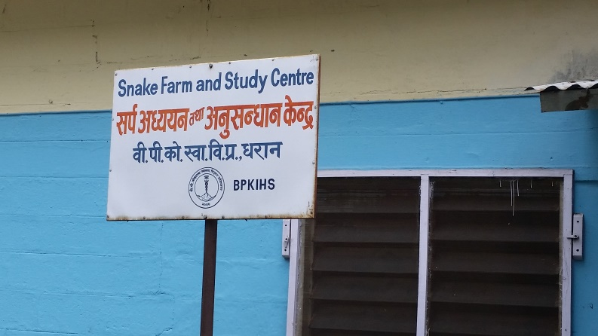Snake Farm and Study Centre is located on the campus of the B P Koirala Institute of Health Sciences Dharan, Nepal.

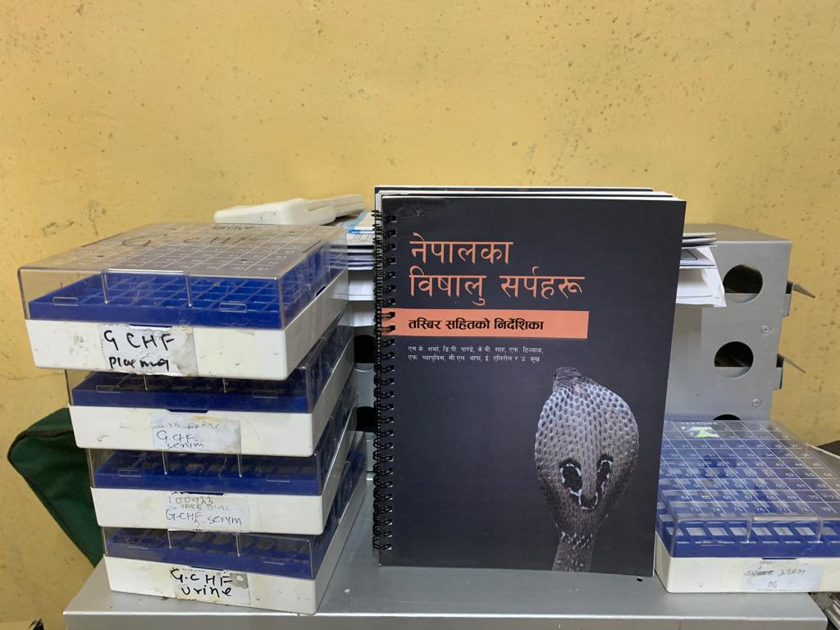

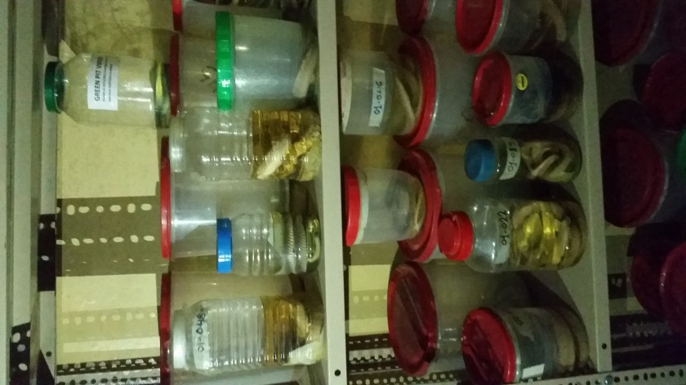

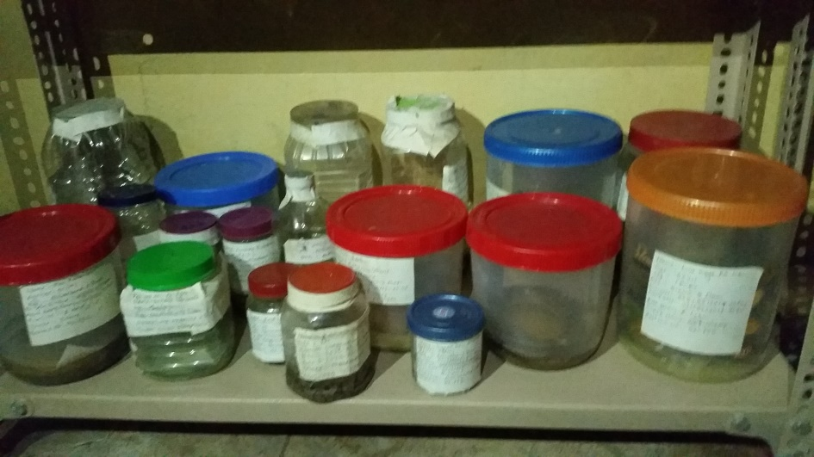

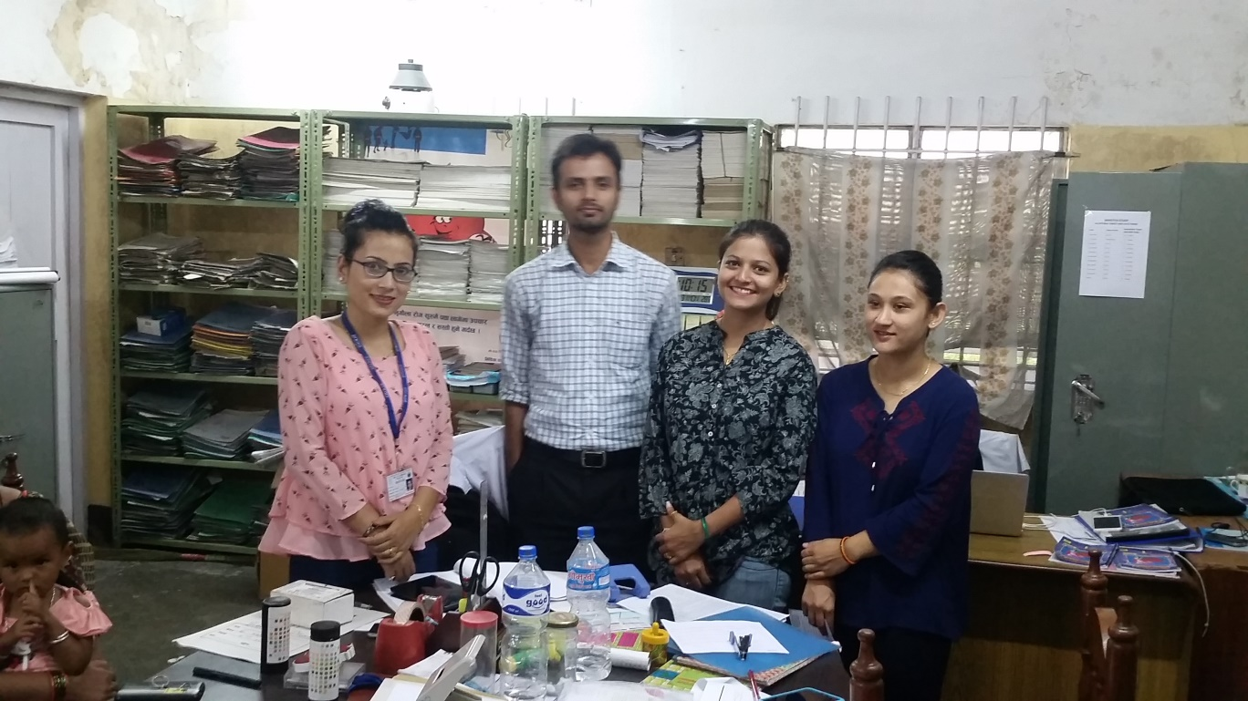

Dedicated staff of the Snakebite Study Research Centre, BPKIHS

===========================================================

**Dr Sanjib Kumar Sharma** and friends conducting field research on snakes and snakebite in Nepal’s Terai region.

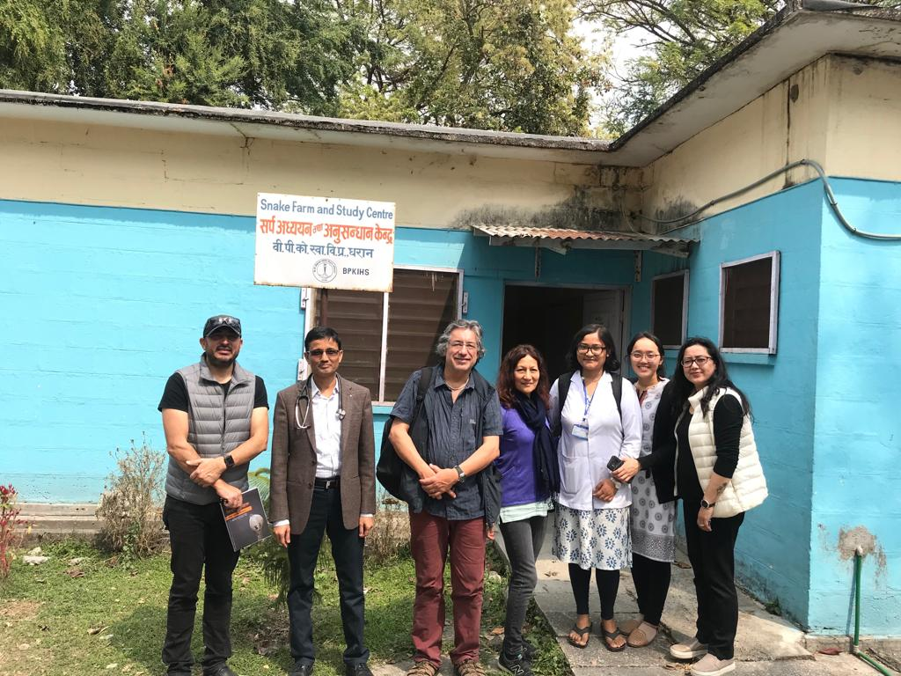

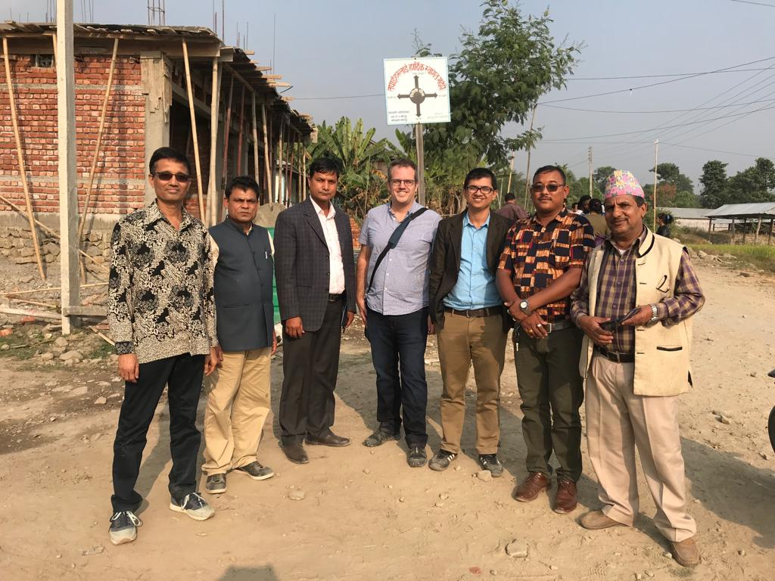

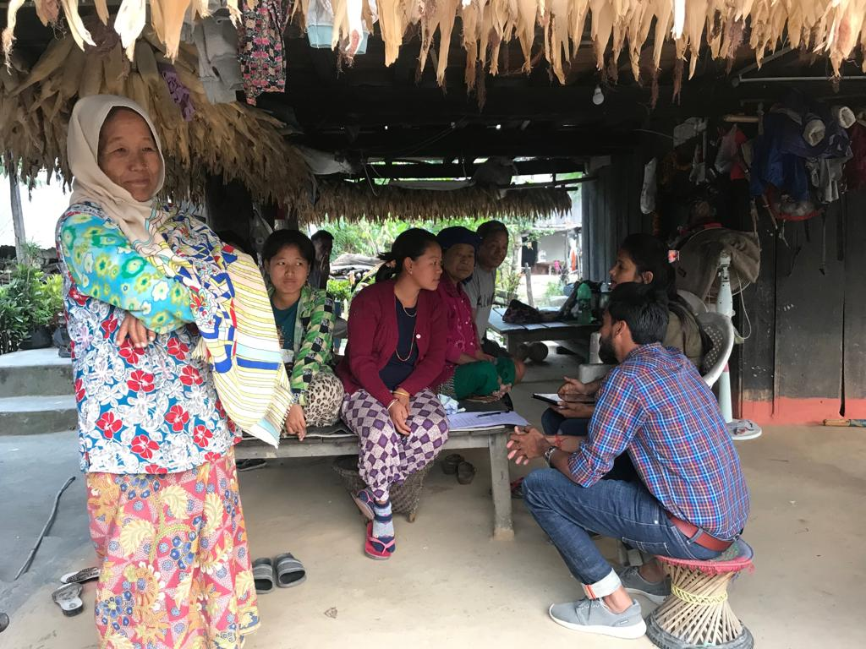

Help from Australia

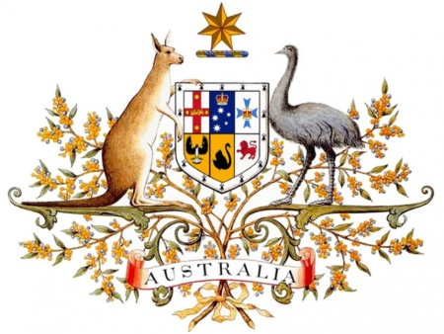

In 2017, the Australian Direct Aid Program funding helped to fund “Training of Practitioners on how to Treat Victims of Snakebite” for 57 doctors and 167 paramedics from the Eastern Terai. In 2018, additional DAP funding helped to train 57 doctors and 141 paramedics**. In total: 114 doctors and 308 paramedics have received training** to date from this fund.

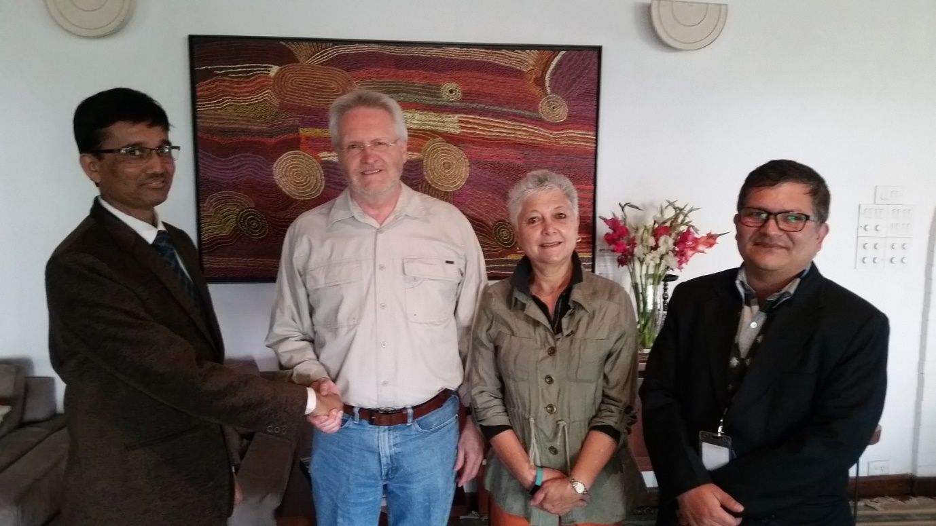

Photo from 2017 on the occasion of early discussions on application for Australian Direct Aid Program (DAP) to fund seminars on treating victims od snakebite. Dr Sanjib K Sharma (left), His Excellency Mr Glen White, Ambassador of Australia to Nepal, (second from left), Mrs Marianne White (second from right) and Mr Krishna Karki (Embassy of Australia Program and Research Officer (right).

**2018**

**TRAINING OF PRACTITIONERS**

**ON HOW TO TREAT VICTIMS OF SNAKEBITE**

Venue: Auditorium Hall, BPKIHS

Organised by: Dept. of Internal Medicine, BPKIHS, Dharan

In collaboration with: Epidemiology and Disease Control Division (EDCD), Nepal

Funded by: Australian Direct Aid Program

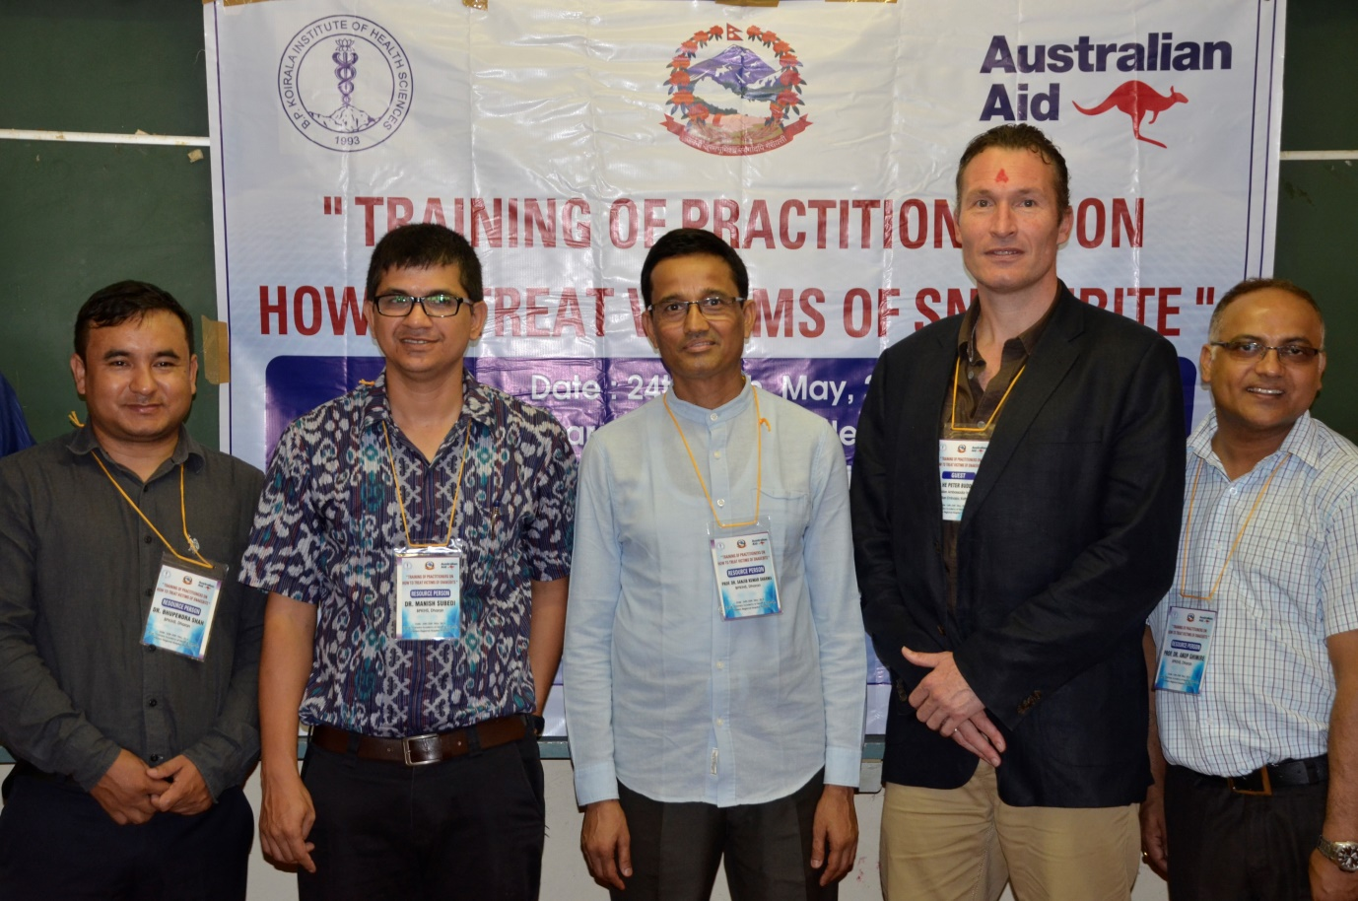

In 2018. Photo left to right: Dr Buphendra Shah, Dr Manish Subedi, Prof Dr Sanjin Sharma, His Excellency Mr Peter Budd (Ambassador of Australia) , and Prof DR Anup Ghimire.

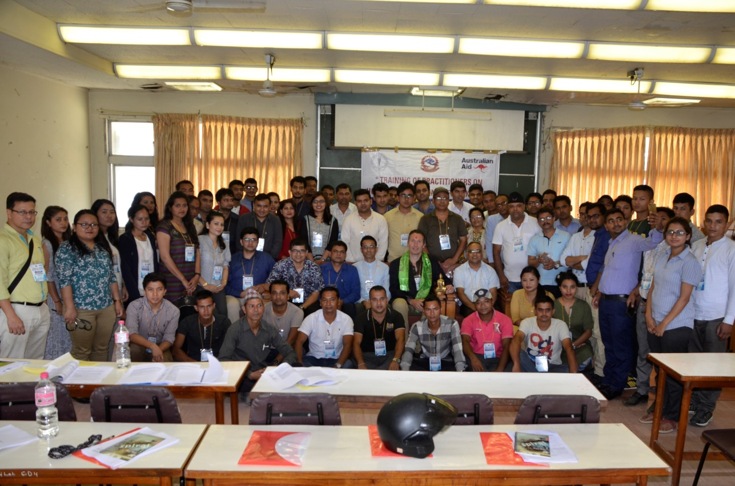

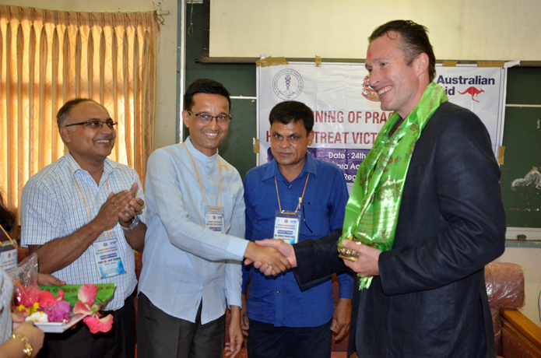

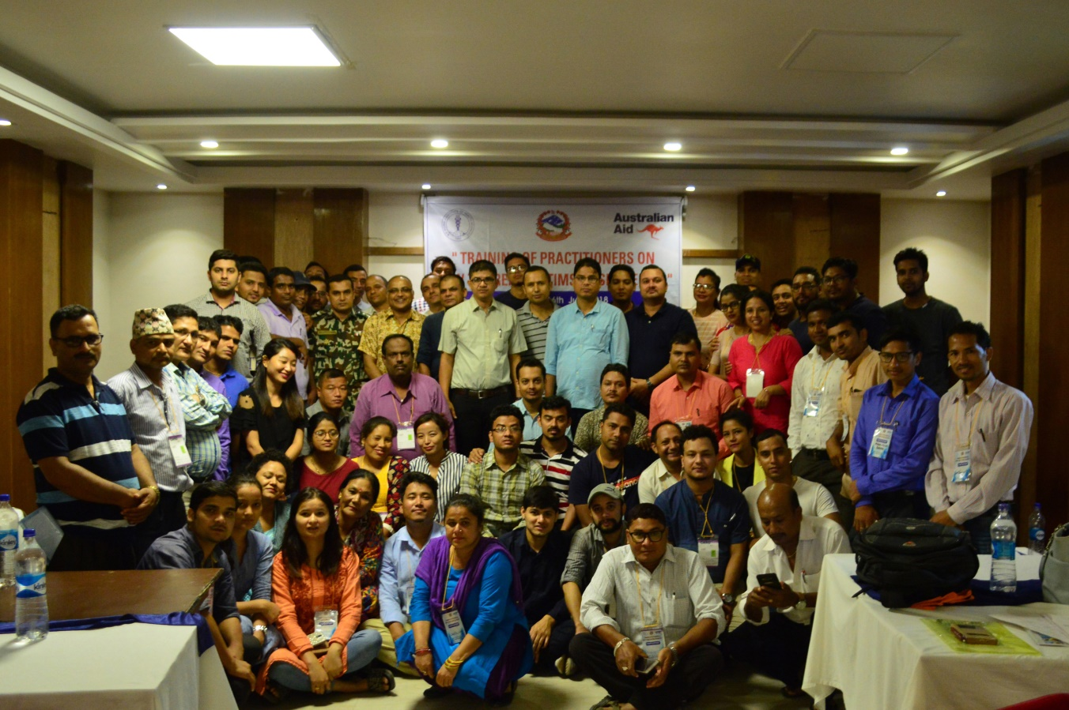

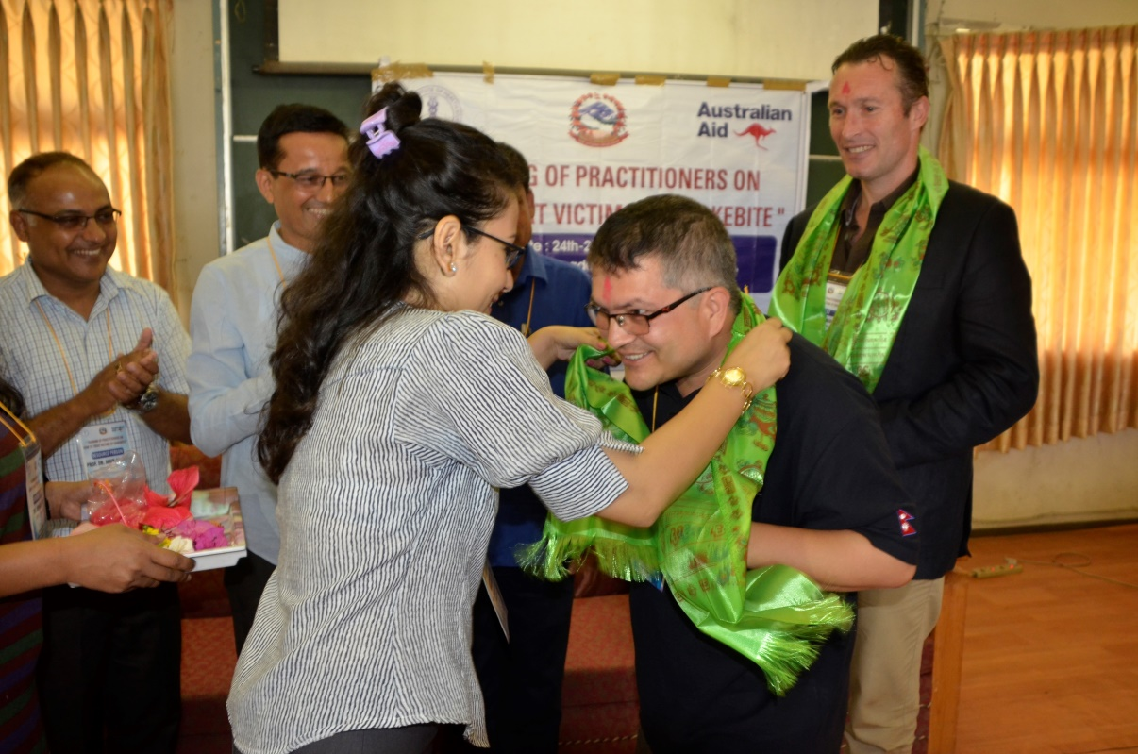

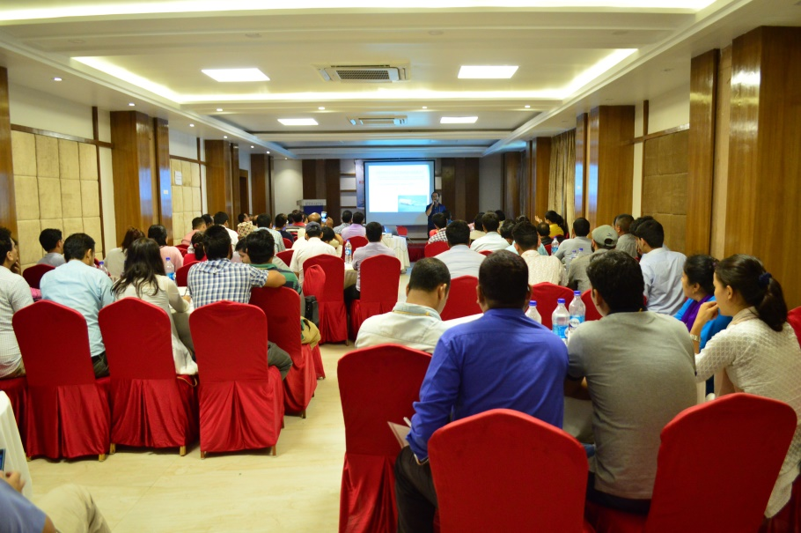

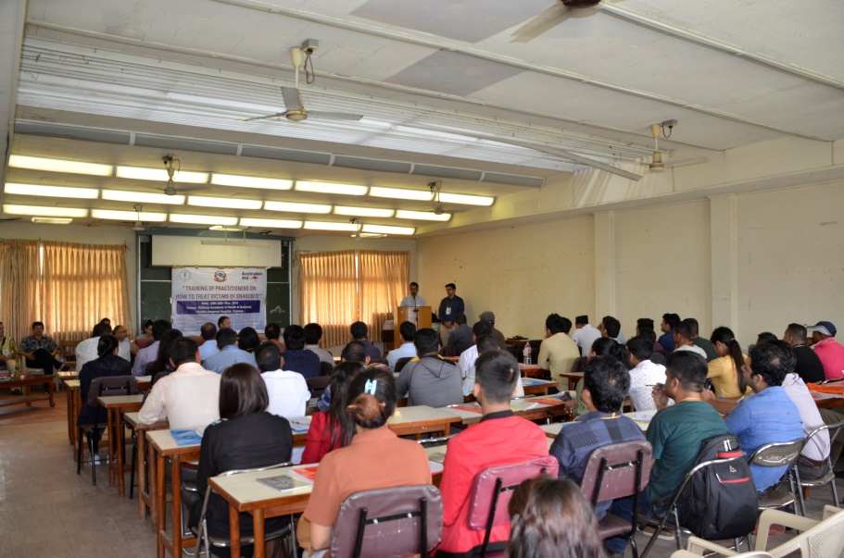

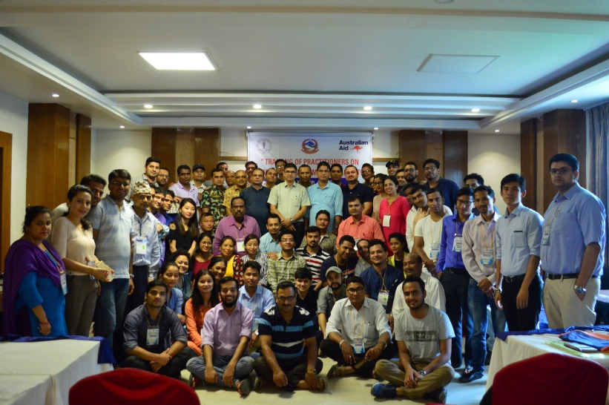

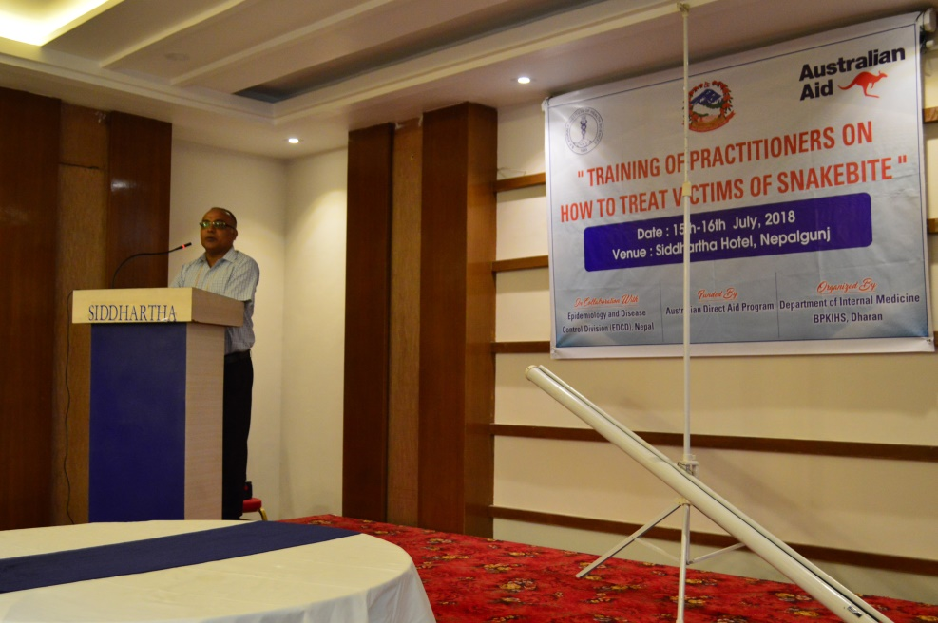

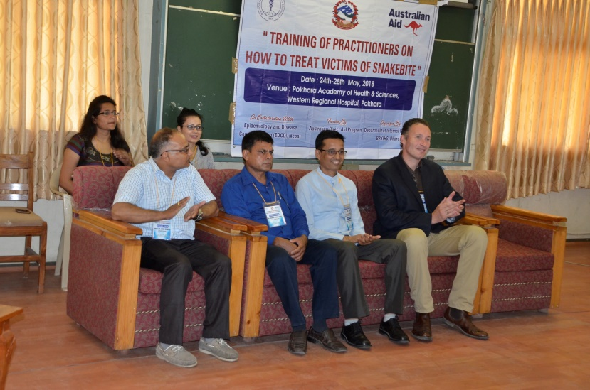

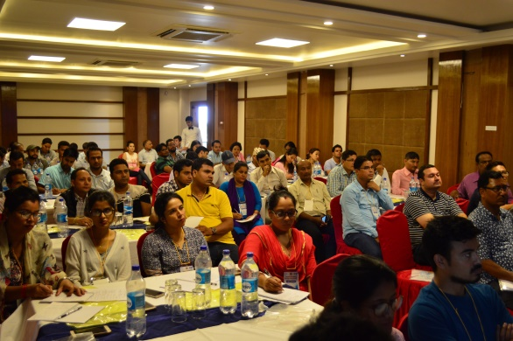

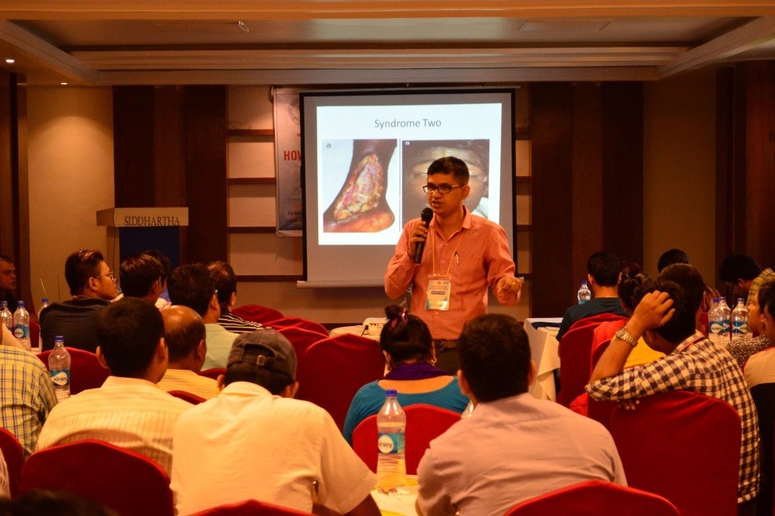

**2017**

**TRAINING OF PRACTITIONERS**

**ON HOW TO TREAT VICTIMS OF SNAKEBITE**

Date: 3rd & 4th July, 2017

Venue: Auditorium Hall, BPKIHS

Organised by: Dept. of Internal Medicine, BPKIHS, Dharan

In collaboration with: Epidemiology and Disease Control Division (EDCD), Nepal

Funded by: Australian Direct Aid Program





**===============================================================**

**The Rotary Club of Kathmandu Mid-Town**



This Rotary Club of Kathmandu Mid-Town is committed to help promote a Nepal where no one dies from snakebite. This Club has been working with Conference Convener, Dr Sanjib Kumar Sharma, and the Snakebite Research Centre at BPKIHS in Dharan for a number of years through the Rotary Club of Kathmandu Mid-Town.

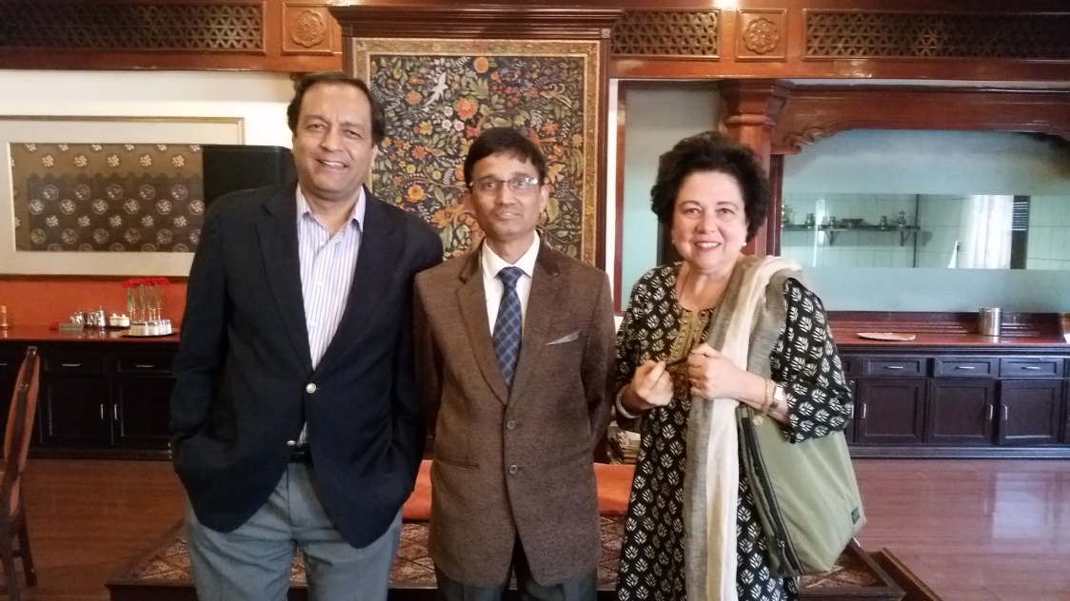

Photo 2017 Left to right: Dr Buddha Basnyat (His Excellency Honorary Consul for Canada)**,** Prof Dr Sanjib Kumar Sharma (BPKIHS, Dharan), and Dr Isabella C Bassignana Khadka (Conference Coordinator).

=====================================================

**Help from New Zealand**



The **New Zealand High Commission Head of Mission Fund** is helping to fund a manuscript for prevention and treatment of snakebite in Nepal. The manuscript is in preparation.

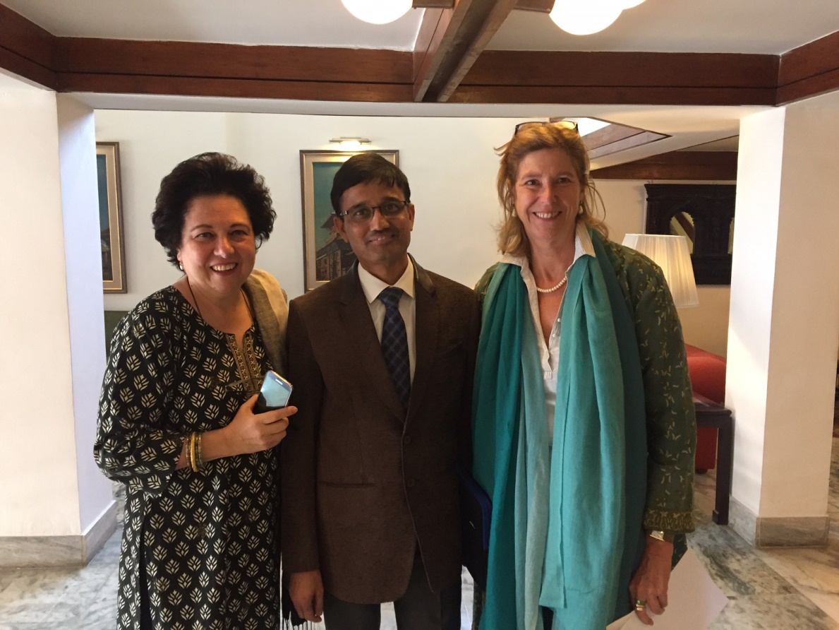

Photo 2017. Left to right: Dr Isabella C Bassignana Khadka, Prof Dr Sanjib Kumar Sharma, and Her Excellency Honorary Consul for New Zealand Ms Lisa Choegyal.